Assignment 1 advanced programming

**Name: Farukh Ahmed**

**CMS: 220247**

**Class: BSCS 7-A**

# WordPress

WordPress is a content management system based on PHP and Usually used with MySQL database servers but can also be used with MariaDB or SQLite engines. It is a plugin architecture and a template system mostly associated with blogging. It is the most popular website management system in use with more than 60 million websites. WordPress was released on May 27, 2003, by its founders, “Matt Mullenweg” and “Mike Little”. To use WordPress, a server must be installed. “WAMP server” is used to install and explore WordPress.

# Configure

Wamp server is installed first on the computer and WordPress folder is copied in the root folder “www”. By opening WordPress from local host, installation process is carried. It asks for user details and a database name where all data is stored. By providing user details, an admin is created and page redirects to the dashboard.

# Explore

After configuration, WordPress redirects to DashBoard as an admin. There are two types of users;

1. Admin.
2. Customer users.

# Admin:

Admin can create new users by filling their info and assigns role. Types of roles are Subscriber, Contributor, Author, Editor and Administrator.

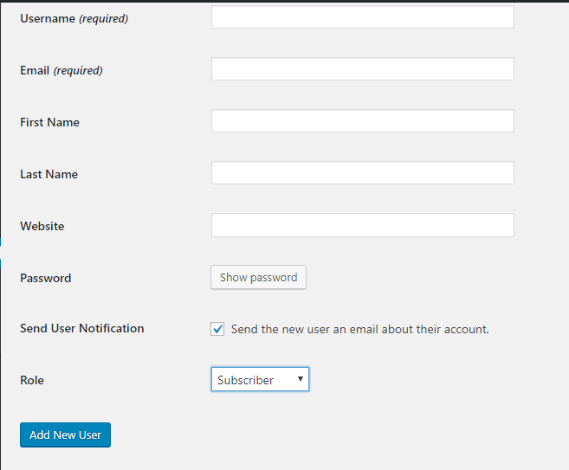

Subscriber can only see posts while contributor can also upload posts. Admin can also make another user admin.

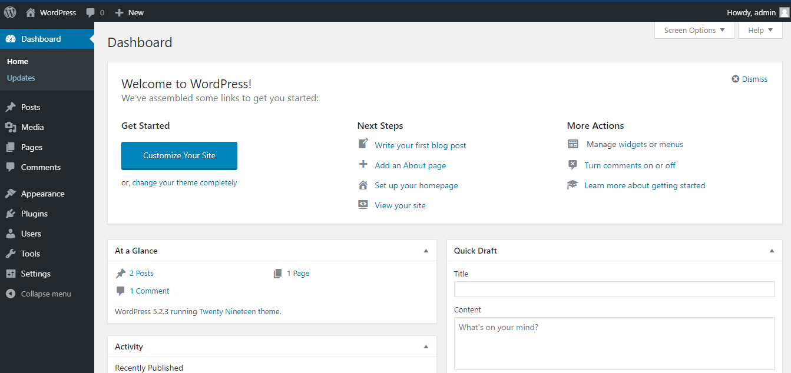At Dashboard, admin can customize site, change theme, write blogs, turn off/on comments. He can also manage users plugins, posts etc.

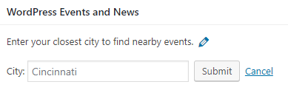WrodPress also have News and Events section. By informing our city, it helps us find nearby news and events.

# User:

By logging in as a user, we have less options in menu bar as user can not control or manage site but as a contributor, user can write blog, see posts, and comment on other’s posts. This specification depend upon which role admin has given to the user.

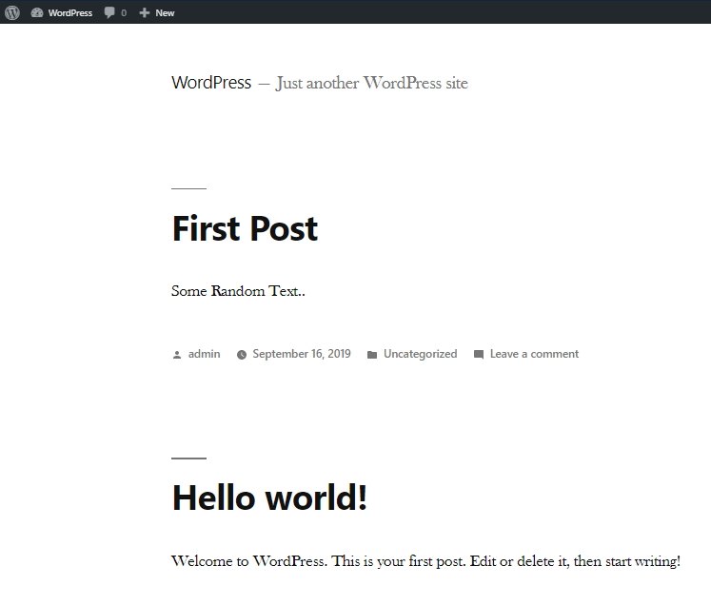

This is index page of user perspective where he can see posts and upload a new posts.

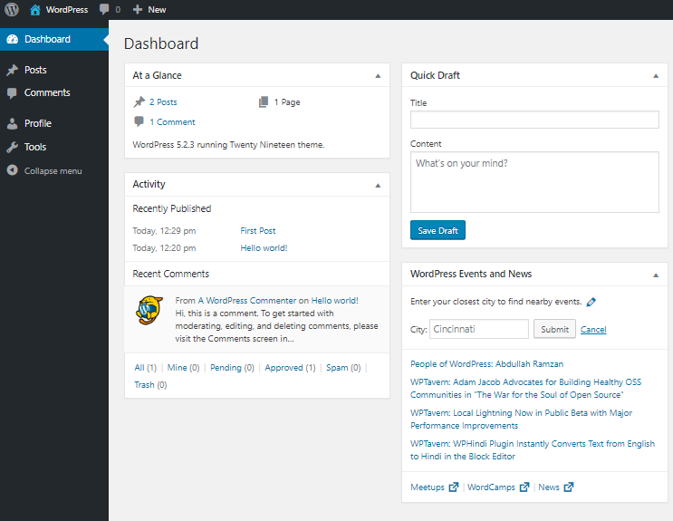

A Dashboard of user perspective. User can also manage his profile and use tools specified by admin.

# Use of plugin

Admin can also install a plugin to make some changes according to required field. External plugin can be imported or WordPress also have three plugins by default.

A default plugin “Classic Editor” enables the old-style Edit Post screen with TinyMCE, Meta Boxes, etc.

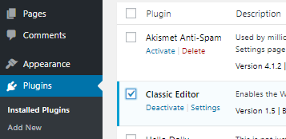

This plugin enables user with more variety of text edits while writing blogs. Options like bold text, italic text, bulleted and numbered lists, aligning etc.

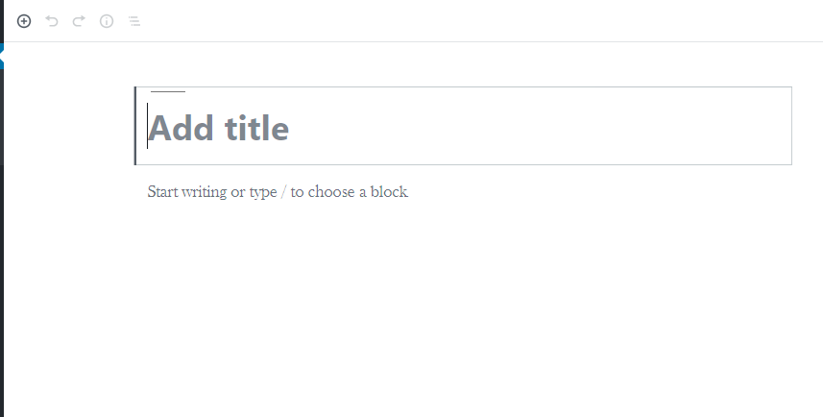

Creating new post without “Classic Editor” plugins gives no options for text editing.

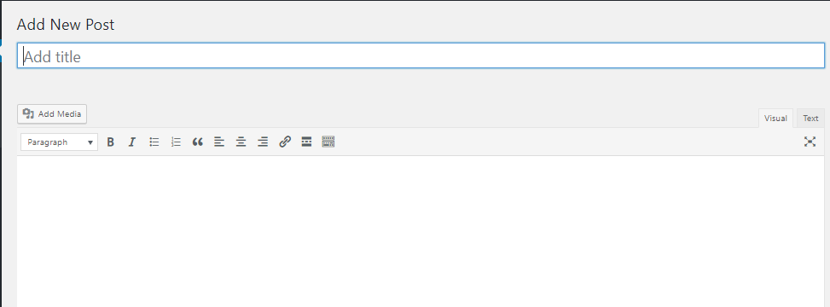

While after plugin is installed, WordPress allows a lot of options. There are thousands of plugins providing different kind of functionalities in WordPress.

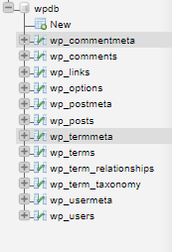

Database

WordPress stores all data tables in the server’s database (i-e: phpMyAdmin). There are different tables for data and metadata. Users are stored in “wp_users” table. It contains admins and all users information. WordPress stores posts, links, comments and terms in different tables.

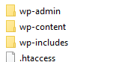Structure

WordPress contains three folders named wp_admin, wp_content, and wp_includes.

Wp_admin folder contains all files related to admin and all settings and tools that are used by admin. It also contains “maint” folder which has repair.php file which is used for restore and backup. It also contains network, user and includes folder.

Wp_content contains all plugins, themes, upgrade and upload files. While wp_includes contains certificates, fonts, images, texts, widgets, customization, requests, apis etc.